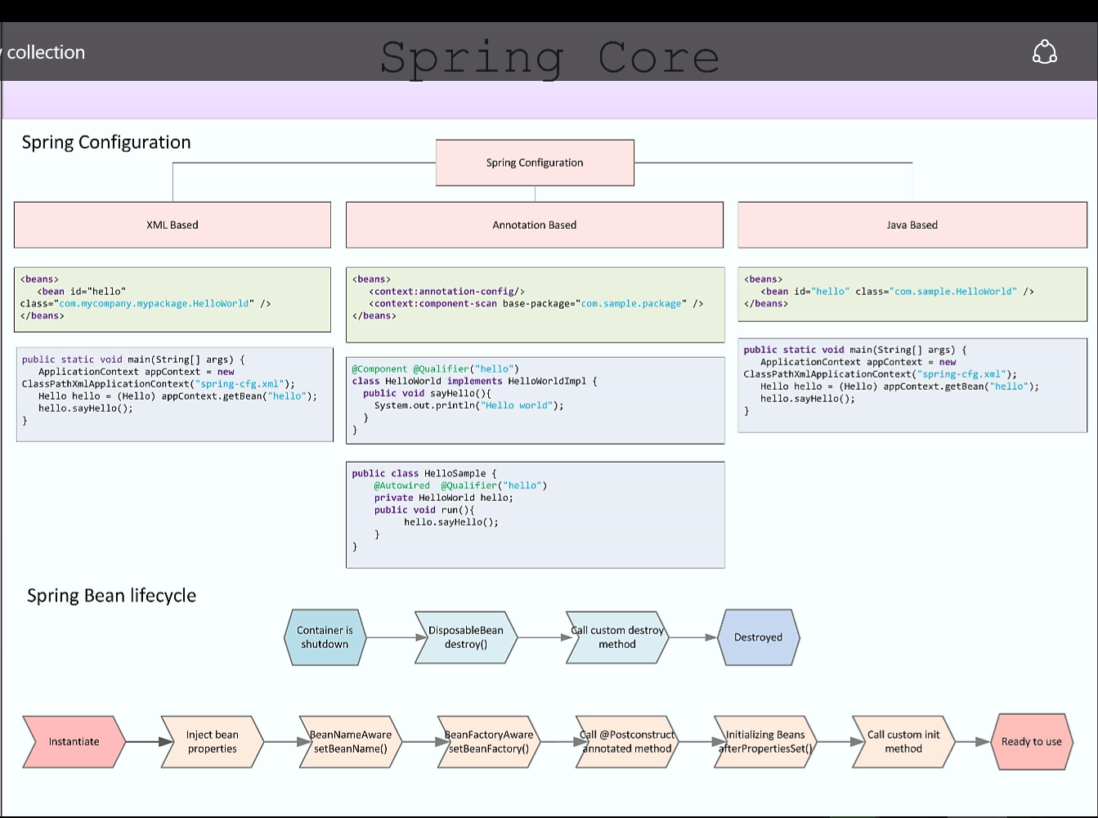

Java Based Spring Configuration

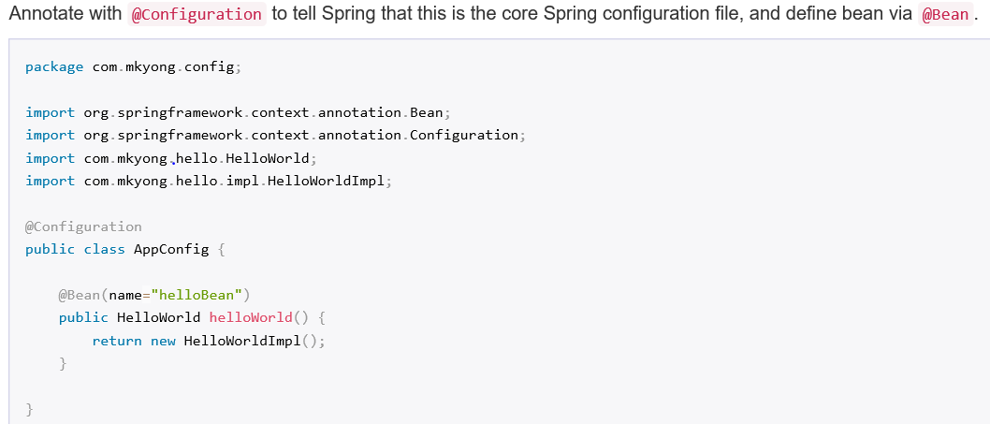

You needs to add cglib library in the maven configuration, in-order to use java based bean configuration.

